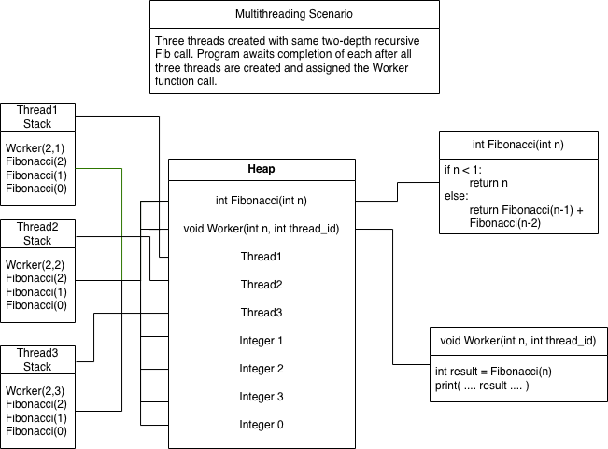

This diagram contains four major areas: the multithreading definition, the thread stacks, the heap, and the function details. This diagram is missing or not fully explaining some of the more exact concepts and program execution/flow. But it attempts to provide an overall sense of the different sections. The multithreading scenario gives the context for how the program sets up the multithreading during execution to attempt to provide some nuance of how the pieces will fit together. The thread stacks contain references to the heap-stored functions and the needed parameter context to execute the specific functions. All three thread stacks are the same since they are all created with identical function calls. The function definitions explain the business logic that is stored within the heap’s function objects in order to help explain the flow and purpose of the program. The heap contains the shared memory amongst all threads and recursion levels in order to provide a consistent reference for what function calls and variables should do or provide. Some of the nuance that is lost in this diagram is how the heap stores the functions vs variables, what is actually stored in the function/object definitions, and the precise flow and state of the thread stacks during execution. Java does not store all of the data grouped in the Heap section of the diagram in the exact same location; a better wording for this diagram may be “shared memory” since the specific heap may not hold all of the variables, thread objects, and function definitions in the lowest level together. In the diagram, the function definitions include a pseudocode for their execution; the heap/shared memory does not actually store the functions as they are written in the program but as their compiled bytecode forms along with meta-level data about the functions. The most important distinction between this diagram and the real-world execution has to do with the thread stacks. For brevity and clarity, the diagram was constructed as is in order to attempt to show how the stack will move through the initial functions down through the recursive function. However, in practice, the initial Fibonacci function call will contain the reference to the object held in the heap along with heap references to the variables needed to be included with the function as context/parameters. This initial Fibonacci call returns an addition of two other function calls which provides the recursive nature of the function. Within the thread’s stack, each recursive call in the return statement of the initial function will produce a new stack for that deeper function call. Furthermore, each side of the equation ( func + func ) will be executed in order. So for higher level Fibonacci calls, the left side of the equation will lead to continued recursion until a base case is reached. For each new recursive call, the thread stack creates a new stack frame for that function. After the base case is reached, that stack frame can be dereferenced and appended to the parent nodes left half of the equation. Once one side of the equation is fulfilled, the other side of the equation will recursively call the function with additional stack frames until that base case is reached. This effectively performs a depth-first pattern; when picturing this process as a tree, one branch will go as far as it can before tracking/solving for the next lowest branch. Once the stack frame is able to return a non-recursive function call i.e. the integer value, that stack frame appends that value to the parent node and is dereferenced within that thread’s stack.
Constraining stack growth in real-world systems is extremely important. Without explicit constraints on stack growth especially for recursive programs, stack overflow can occur fairly easily. This can lead to varying issues for the program or software in which it occurs. In Java and many other major languages or operating systems, this generally leads to the program (or OS) creating an error which will likely crash the program in production. For businesses, a program crashing can lead to a damaged reputation, loss of revenue, and potential safety concerns depending on the software’s application. However, some languages may not explicitly catch this issue which can lead to other dangerous and security issues outside of just a crash; it could potentially overwrite other sections of memory. This is extremely problematic because it could lead to overwriting important data stored in, believed-to-be secure, memory addresses. The security issue this leads to is when a malicious actor may abuse this access to memory outside of the stack to attempt to insert malware or bugs, steal data, or execute a DOS attack.
This diagram and the simple implementation of a Fibonacci function doesn’t really exemplify concurrency risks like other programs or problems may. The biggest current issue would be amplifying the area that is vulnerable to stack-growth issues if memory management is not properly implemented in a production system. The main risk when dealing with concurrency is the creation of race conditions where multiple threads are trying to manipulate or access mutable data structures/objects held in the heap. Since this program does not contain any, it isn’t an issue. However, if the program did contain a global list that was used to store the results, this could provide the necessary environment for race conditions when not properly guarded against. If multiple threads were to attempt to write the results to this data structure all at once it could lead to unpredictable behavior and/or overwriting the data stored by one of the other threads.
The most common synchronization technique to avoid race conditions from multithreading is the use of locks. By implementing a lock, the data object is able to be protected from multiple threads attempting to access it at once. There are multiple implementations available for synchronized locking, but the simplest one involves locking variables when a thread first interacts with it which blocks any other thread interactions until the lock is unlocked after the current thread is done with it. Another option in Java is the use of atomic variables, but they are commonly used for more simple implementations and not logic-heavy interactions.

